Agriculture

In this project, you will compare agriculture data from 4 major countries. Use this website to locate your data: http://www.nationmaster.com/index.php

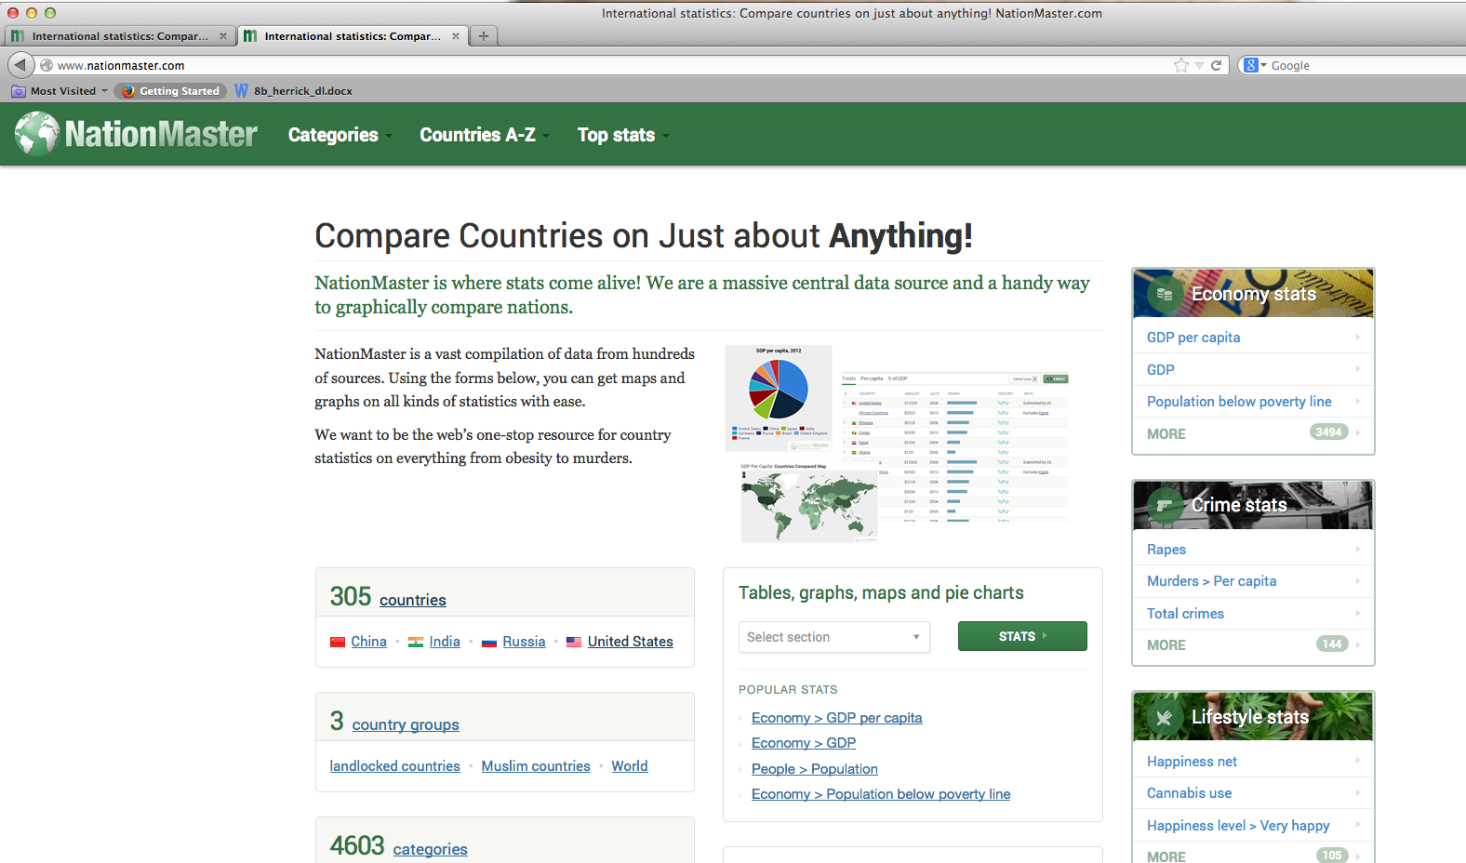
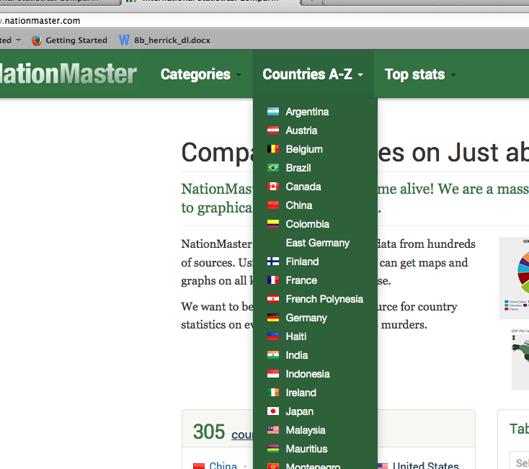
Select a country. We will use United States, United Kingdom, China and India. In each country, you will look at the Agriculture link.
Website looks like this. You will get your source data here.

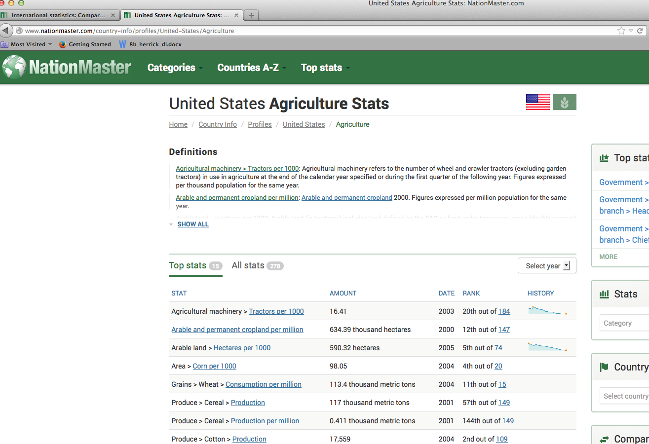
Find your stats and record on spreadsheet. Go back to green bar and to Countries A-Z and repeat for each country. We will use Cereal Production, Meat Production, Tractors, Fertilizer Use.
- A1 put a title and A2 put your name
- Enter the country names as labels using Column A
- Enter the agricultural item labels to compare in row 4.
Agriculture | 10 pts. | 8 | 7
Objective 1: Enter and work with data in a spreadsheet and format data and use formulas and functions | Entered all data correctly. Completed required formatting, used formulas and functions correctly, used advanced formatting techniques to design spreadsheet | Entered all data correctly, was able to format some of spreadsheet, attempted to use formulas and functions | Entered most data correctly, some incorrect formatting, some formulas and functions used
Objective 2: Create bar charts to analyze data | Created required charts with correct elements including title, names of axis, legend, and data labels; correct data displayed; used advanced charting techniques to design charts beyond requirements | Created minimal charts with correct data displayed | Created minimal charts, some formatting, some incorrect data
Objective 3: Create pie charts to analyze data | Created required charts with correct elements including title, names of axis, legend, and data labels; correct data displayed; used advanced charting techniques to design charts beyond requirements | Created minimal charts with correct data displayed | Created minimal charts, some formatting, some incorrect data
- Do not use any words with number data to describe it. Instead, put that description in your label. Ex: lbs., dollars, etc. You will also need to make this column wider.

Once you have collected and entered your data, create a pie chart for each of the agricultural items being analyzed (one for Cereal Production, etc.) Since you will be using data that is non-adjacent to each other, remember to use the Command key.

In a cell below the charts, list 1 conclusion you could make from looking at the charts. After you have typed that, click on the Wrap Text Box to make it all fit in the box.
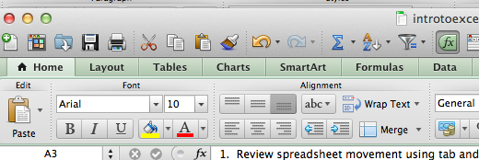

Once the spreadsheet is completed, save it as class_lastname_countries and email to me as an attachment.

Rubric: 30 pts. possible

