Creating Charts
Charts bring data to life! Spreadsheets and Charts go together like peanut butter and jelly!! In this project you will first learn how to create a chart quickly from your data. Then you will learn how to format the chart to make it attractive and easy to read. (Open the Hamster Data spreadsheet.)

Highlight cells A3 through C15.

Click on the Chart Tab and then select Column.

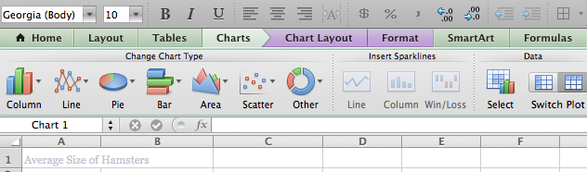

Something similar to this should appear on your screen:
Note that there is no title on this chart. To add a title, go to Chart Layout tab and then Chart Title.
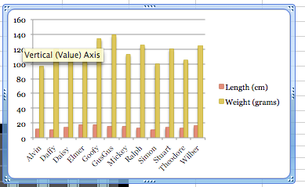

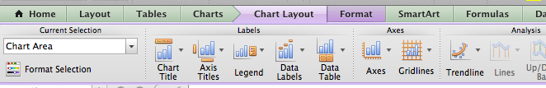

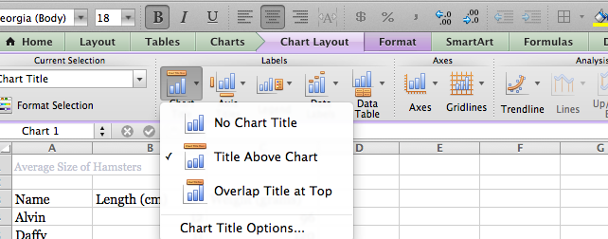
From the Chart Title drop down menu, select Title Above Chart. Title your chart “Average Size of Hamsters”. Save as Class_lastname_Hamster

