SPREADSHEET GROCERY SHOPPING PROJECT

Purpose:
- Locate pricing information using the Internet (see second page for link)
- Create a spreadsheet of information using Excel formulas to multiply and add data
- Stay within a budget

Procedure:
For this project, you will be planning a party for the class for the day before spring break. Before you begin, write out a plan for what you need (a grocery list using a Google Doc). Don’t forget small things like condiments, paper plates, cups, etc. What will you need for the food you are planning? Your budget will be $8 per person in this class. Keep in mind that you are trying to find a food of substance, sweets, and something to drink AND you need enough for everyone. After you have begun planning, set up your spreadsheet in Excel similar to below (insert as many rows as you need before the Totals section. Insert appropriate formulas where indicated. Be sure to widen columns as needed to make the spreadsheet look nice; all of it should fit on one page

.

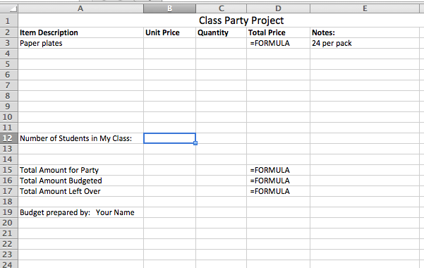

Extension:
Write a letter to me using Word and explaining to me exactly what you plan to do for the party (what will we be having, will we play any games, etc.). If you are over budget, explain why and justify your reason. Save both documents using class_lastname_grocery and email to me as attachments. Use one email and attach 2 docs. You may use your class name in the subject line of the email

Shopping at WalMart (should come to page that looks like the following)

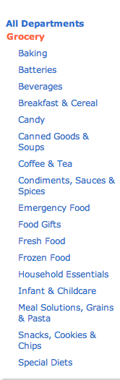

Steps in this project:
- Open Excel and create a spreadsheet like the one shown above.
- Go to this website and select your items.
- Record how many and price on your chart in
appropriate columns.
- Put in appropriate formulas where needed.
Remember to start each with = sign. HINT: you will need a formula in each cell of Column d where you have an item to purchase AND you will need formulas below to find the total amount for the party, the total amount budgeted, and any money left over or over-spent.

Grocery Shopping | 20 pts. | 19-17 | 16-14
Objective 1: Enter and work with data in a spreadsheet and format data and use formulas and functions | Entered all data correctly. Completed required formatting, used formulas and functions correctly, used advanced formatting techniques to design spreadsheet | Entered all data correctly,was able to format some of spreadsheet, attempted to use formulas and functions | Entered most data correctly, some incorrect formatting, some formulas and functions used

