Movie DVD Prices•

Use the spreadsheet to answer the questions below:
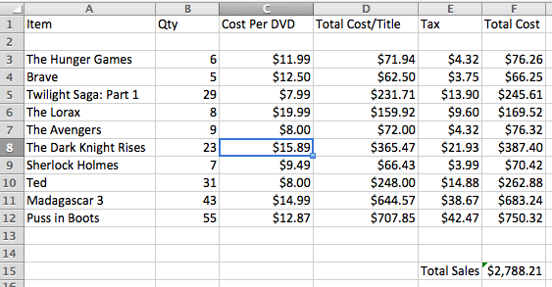

- What is the cell address for the Tax on Hunger Games? _______________

- What is the Total Cost of the order for Brave? ________________

- If you change the Qty of Ted DVDs, which other cells will change as a result? ____________

- How much does 1 copy of Madagascar cost? ______________

- Which cell is active? ___________

- What is the amount of total sales here? _________

- Purchasing 3 Avengers DVDs will cost how much? ___________

- How much tax was paid on the Puss in Boots sale? ___________

- Write the formula that would appear in cell D3. ___________________

- Write the formula that would appear in cell F15. ______________

