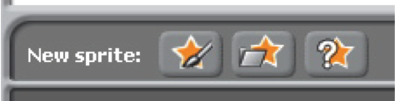
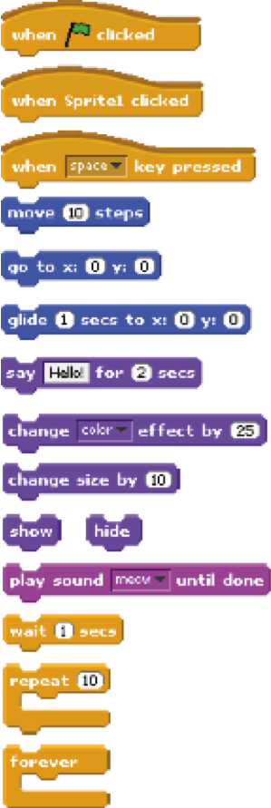
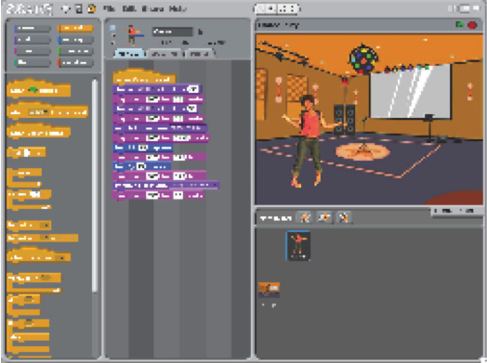
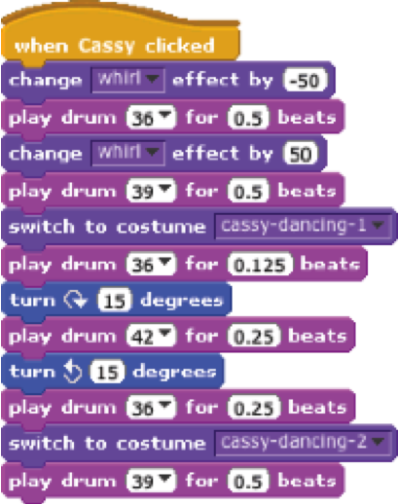
DANCE PARTY
Create your own interactive dance party where sprites
get down with cool costumes and funky beats.

STEP BY STEP...
BLOCKS TO PLAY WITH…
1. Add a sprite

3. Repeat!

2. Make it interactive

paint your
own sprite

get a surprise sprite

choose a downloaded
or library sprite

snap blocks
together to make
your sprite dance

make your
sprite interactive
by adding scripts
that have the
sprite respond
to clicks, key
presses, and
more
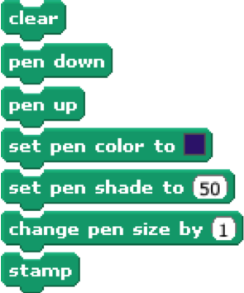


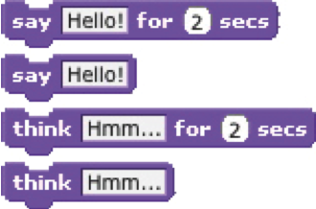
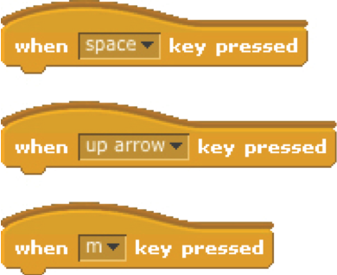

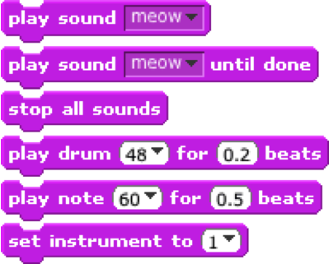
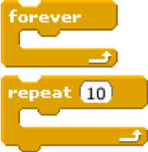
ARTS

Here are some blocks that can be useful in arts-themed projects.
WAIT
Play recorded and synthesized audio
Insert a pause
Have a speech or thought bubble
appear over a sprite
SOUNDS
VISIBILITY
LOOP
SAY/THINK
RANDOM
PEN
Leave visual lines and sprite stamps on the stage
Repeat stacks of blocks
Make a sprite appear or
disappear
Get a computer-generated number from a specified range

KEY PRESS
Make a sprite respond when different
keys are pressed
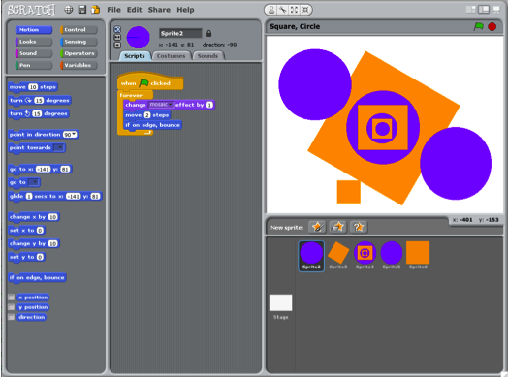
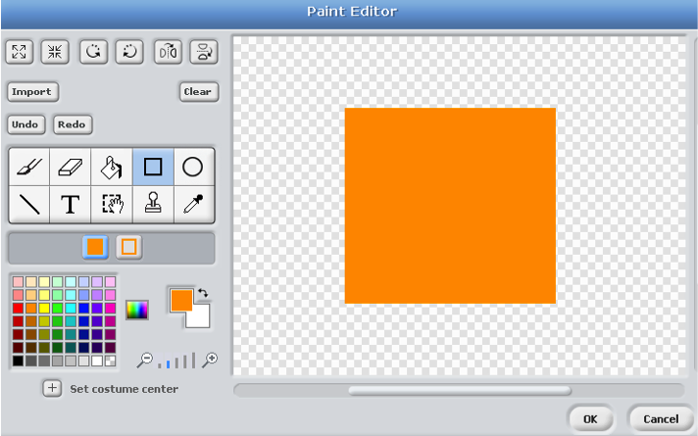
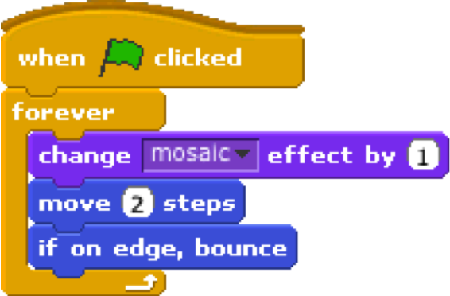
SQUARE, CIRCLE
What project can you create that includes an
orange square and a purple circle?
use the paint editor to design sprites that incorporate an orange square and a purple circle

experiment with different motion and looks blocks
to bring your sprites to life

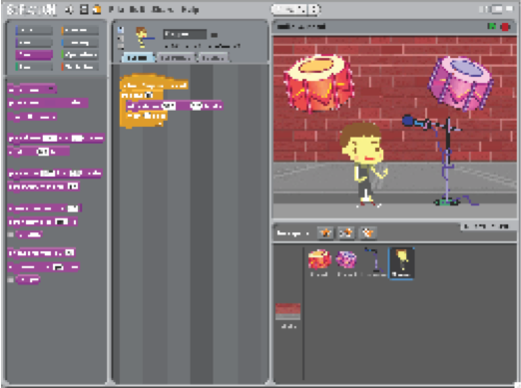
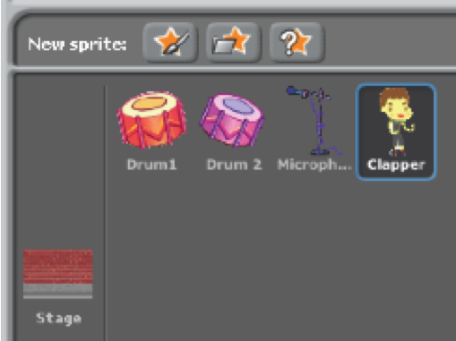
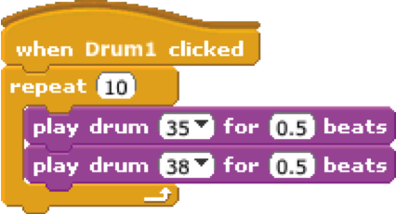
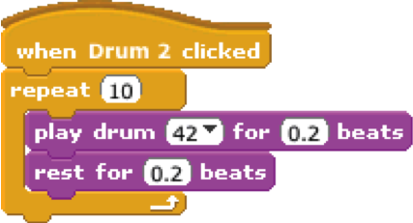
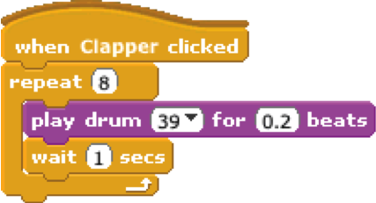
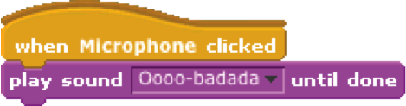
BUILD-A-BAND
Create your own musical group by pairing sprites
with sounds to make interactive instruments.

use the repeat block
to make a sound play
more than once

experiment with different
music and beats, or
import your own sounds
no scripts

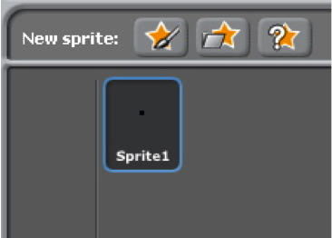
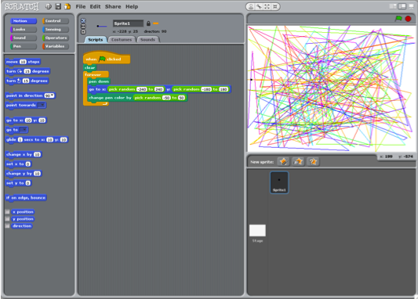
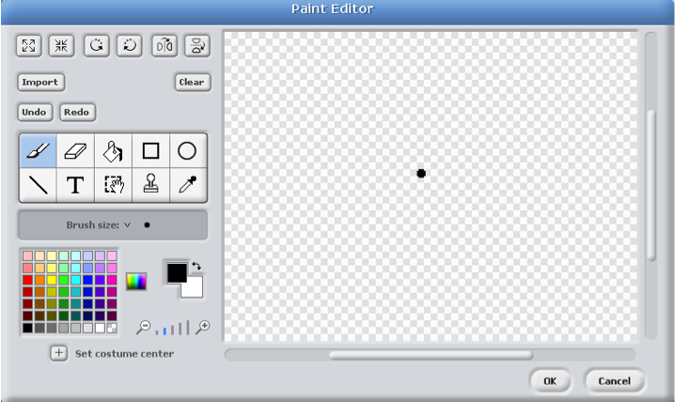
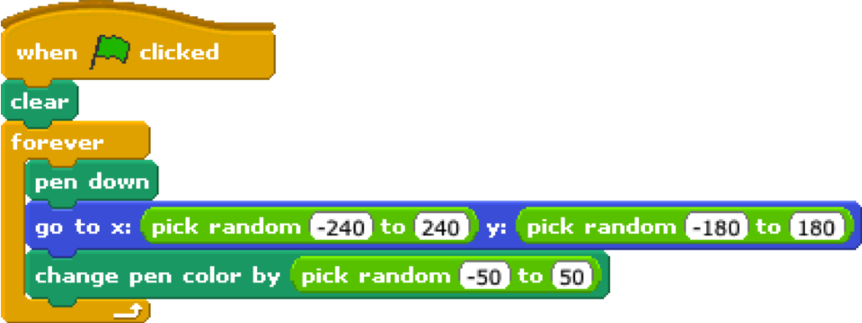
AUTOMATIC DRAWING
Make a project that draws something on its own.
create a sprite that
is just a small dot


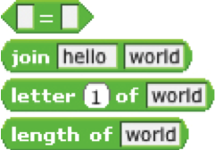

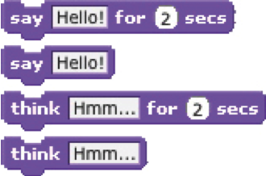
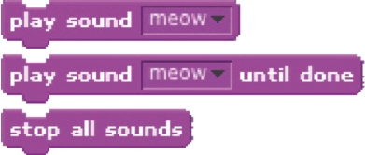
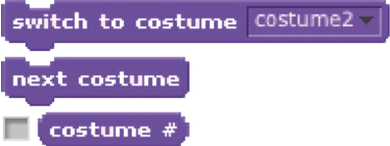
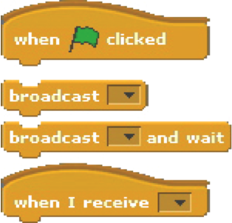
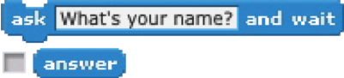
STORIES
Here are some blocks that can be useful in story-themed projects.
WAIT
Play recorded audio
Insert a pause
Have a speech or thought bubble
appear over a sprite
SOUNDS
VISIBILITY
COSTUMES
SAY/THINK
STRINGS
ASK
Get input to use in a project
Change the appearance of your sprite
Make a sprite appear or
disappear
Test, access, and change
words and sentences

COORDINATE
Synchronize actions between and
within sprites
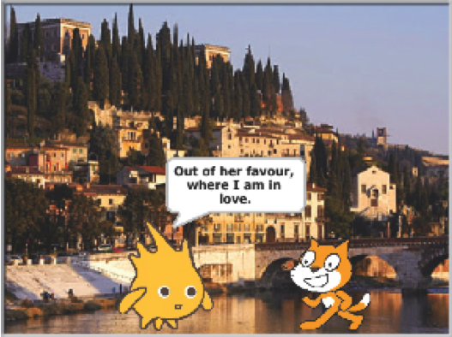
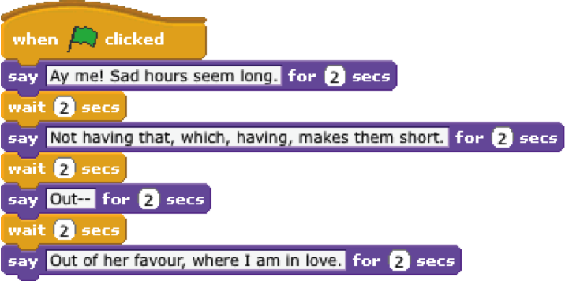
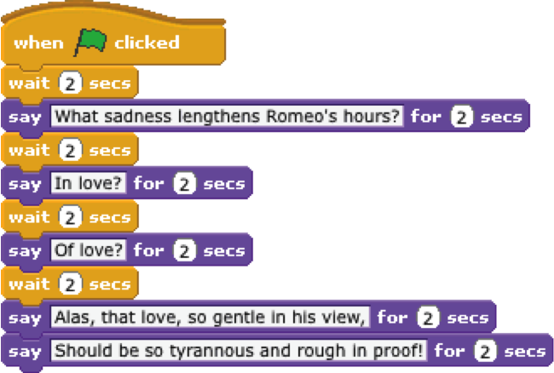
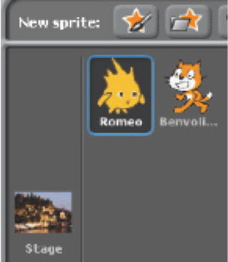
CONVERSATION
Get two characters talking to each other.
Use the say and wait blocks to coordinate
the conversation.
no scripts
add a background
1 script
1 script
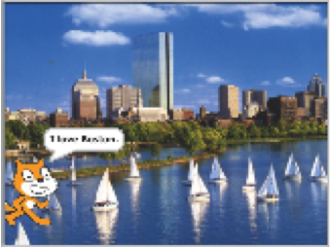
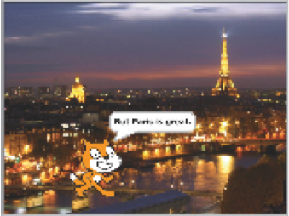
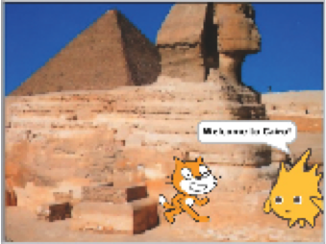
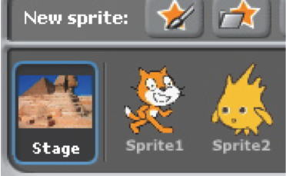
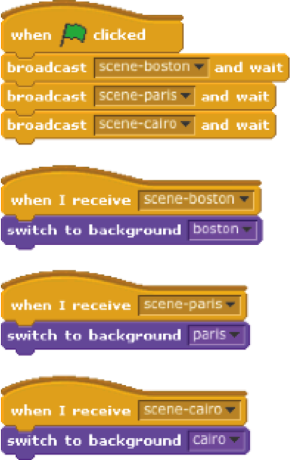
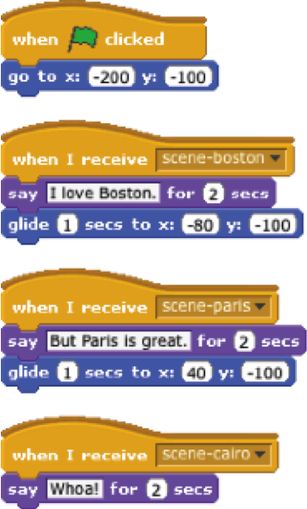
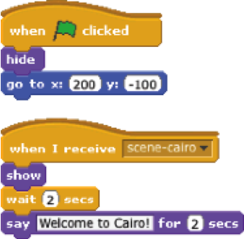
SCENES
add 3 background images

4 scripts
4 scripts
Use the broadcast and when I receive
blocks to create a multi-scene story.
2 scripts
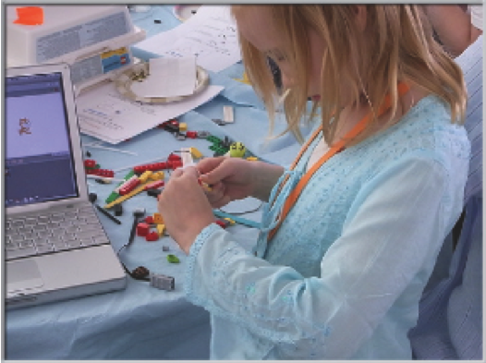
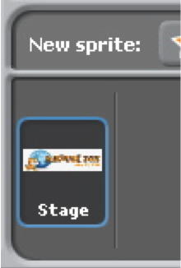
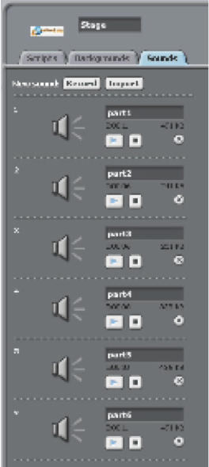
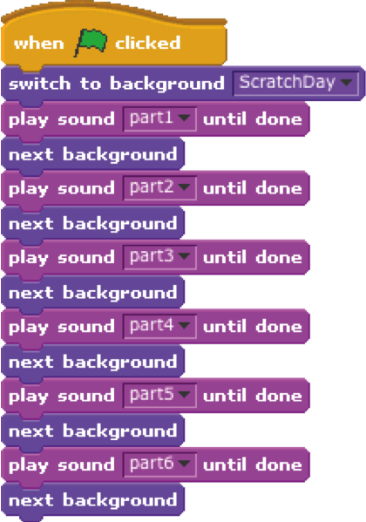
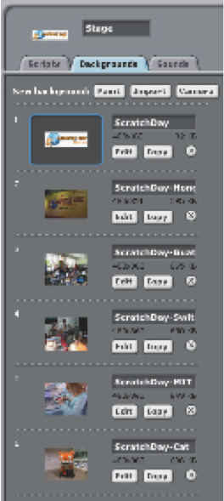
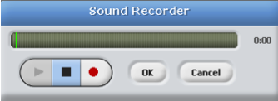
SLIDESHOW
Create your own slideshow – a collection of background images accompanied by audio narration.
1 script
6 background images
6 recorded sounds
record your narration right in Scratch
with the sound recorder
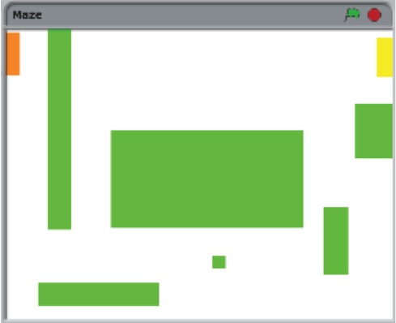
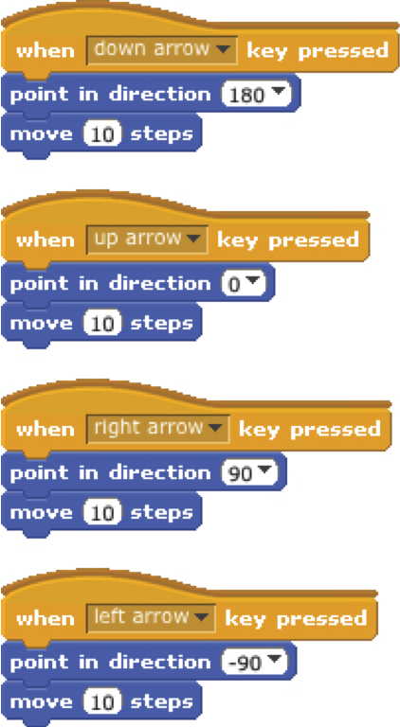
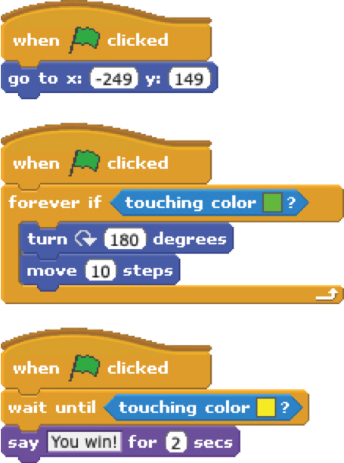
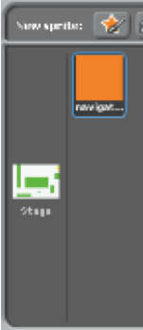
MAZE
Create a game where you get a sprite from the start to the end of a maze without touching the walls.

7 scripts total
have the sprite bounce off the green walls

move the sprite around
no scripts,
draw a maze-like
background with
colored walls and
a differently colored
end marker
players wins when sprite
reaches the yellow end marker
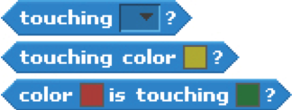
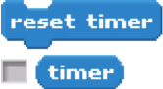

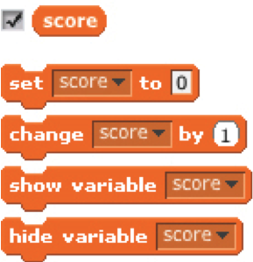
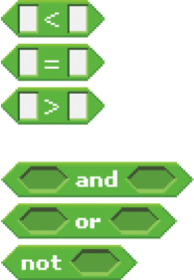
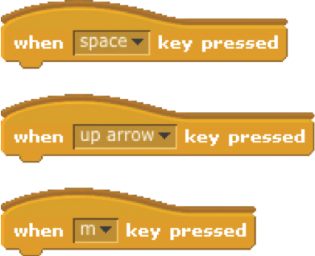
GAMES
Here are some blocks that can be useful in games.
TOUCHING
Get a computer-generated number
from within a specified range
See if two sprites are touching or
if a sprite is touching a color
Make a sprite appear or disappear
RANDOM
TIMING
STRINGS
VISIBILITY
KEY PRESS
COMPARE
VARIABLES
Store a number or string in a
container to access later
Test, access, and change words
and sentences
Have the computer keep track of
time for you
Make a sprite respond when different keys are pressed
Compare values to help make
decisions within your game
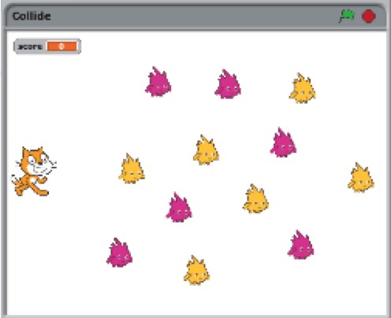
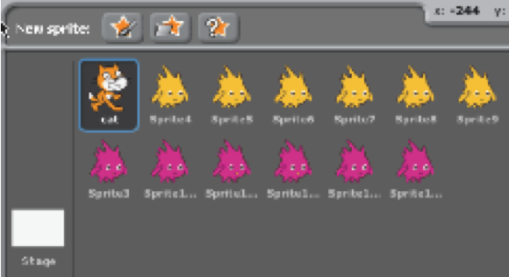
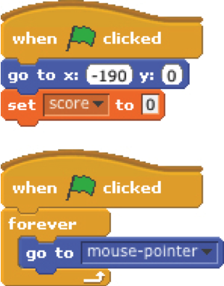
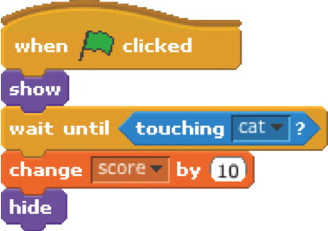
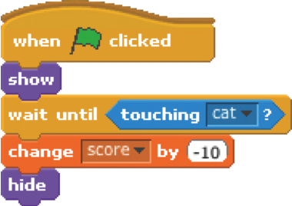
COLLIDE
Help the cat navigate a field of Gobos. Collect yellow gobos to earn points,
avoid pink gobos to avoid losing points.

reset the cat’s position
and the score
when the cat collides with a
yellow gobo, the gobo disappears
and the score increases by 10
no scripts

when the cat collides with a
pink gobo, the gobo disappears
and the score decreases by 10
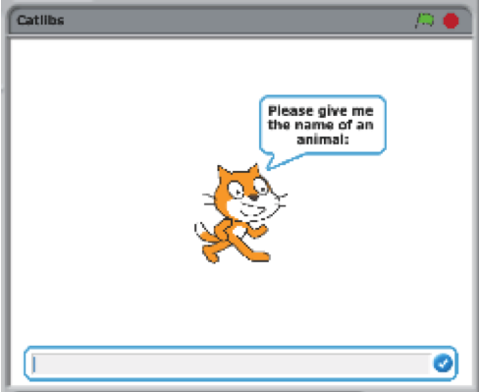
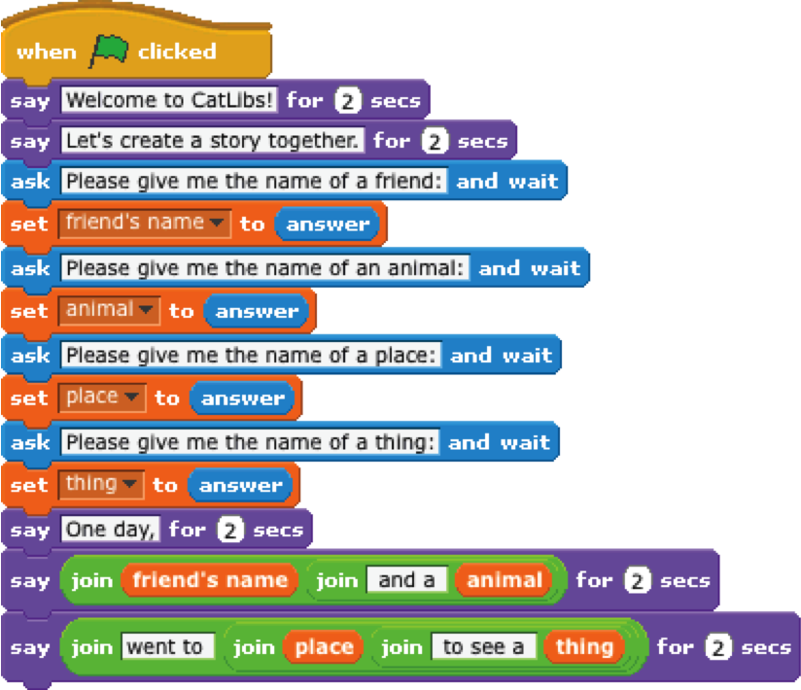
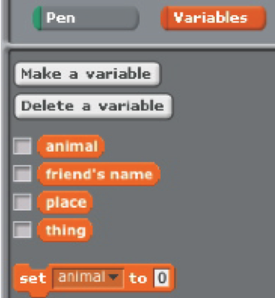
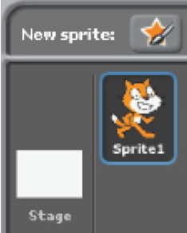
CATLIBS
Create a unique Madlib story by collecting user input.
no scripts

1 script
4 variables

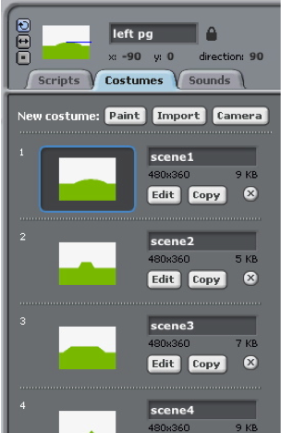
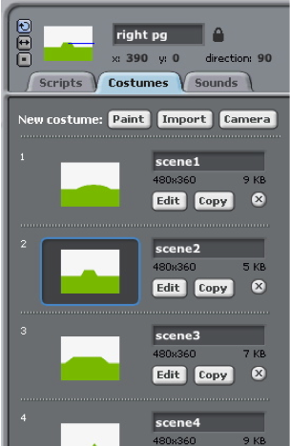
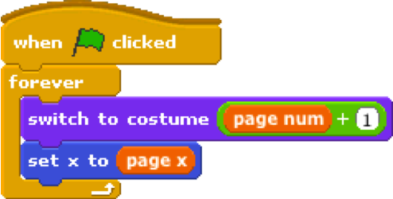
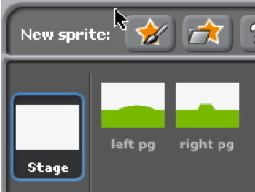
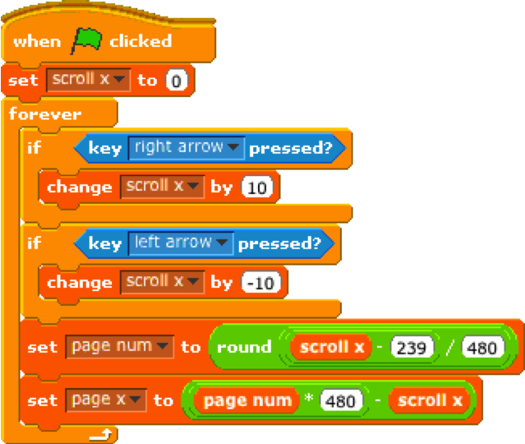
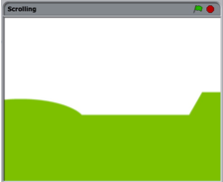
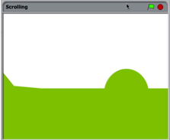
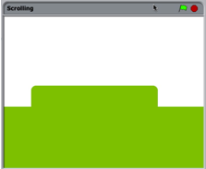
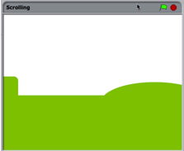
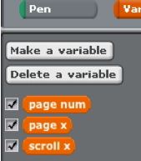
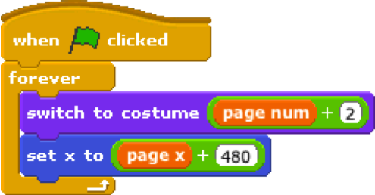
SCROLLING
Create the
foundation
for a side
scrolling
game.
create two sprites:
one for the left background panel,
one for the right background panel

add the same (2 or more) costumes to each sprite

add this script to the left sprite

add this script to the right sprite

3 variables

1 script

