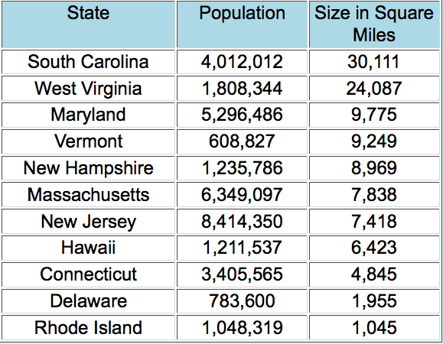
For this activity you will use a spreadsheet to determine how many people per square mile various States have. The Population spreadsheet has been completed for the 10 Smallest States. You will create a new spreadsheet in Excel. Copy the information given in this spreadsheet. In cell D1, use the label People Per Sq. Mile. Enter a formula to figure how many people there are per square mile. Use the fill handle to finish the column. Save your work as class_lastname_states and email me a copy.

